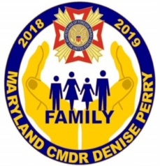
DEPARTMENT OF MARYLAND
VETERANS OF FOREIGN WARS

2018 -2019 STATE COMMANDER SHIRT ORDER FORM
(SHORT SLEEVE POLO)

color

SMALL thru 3XL - $35 4XL thru 6XL - $40

1 | SIZE | COST EACH | TOTAL
2
3
4
5
6

TOTAL ODER - $ __________ (MAKE CHECKS PAYABLE TO DEPT OF MD VFW)

MAIL ORDER TO: DENISE PERRY
2902 ANCON CT
EDGEWOOD, MD 21040

